Book

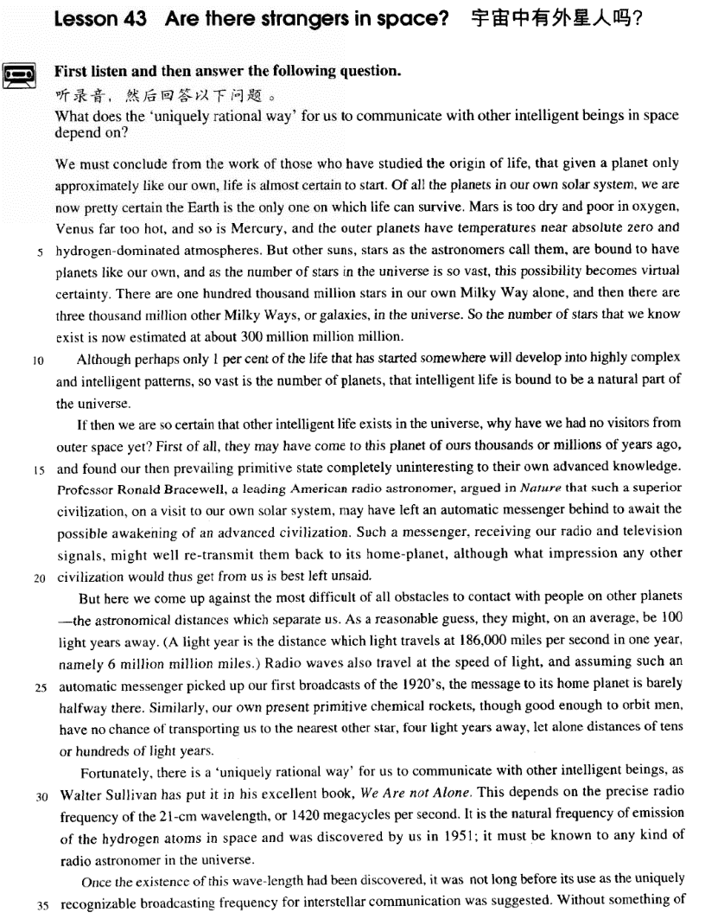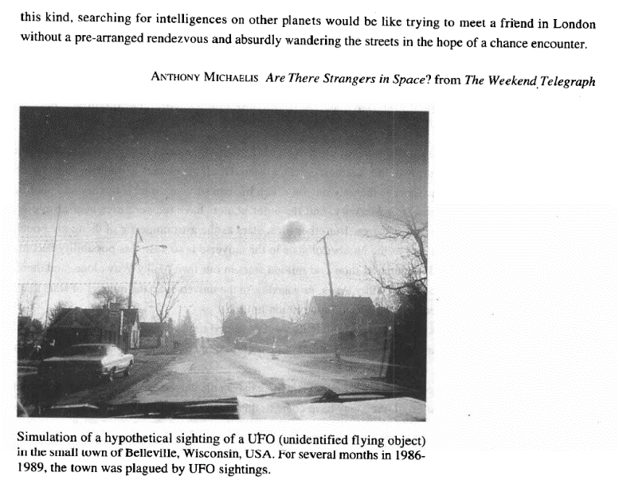

课文

We must conclude from the work of those who have studied the origin of life,

根据研究生命起源的人们所作的工作，我们必然会得出这样的结论：

that given a planet only approximately like our own, life is almost certain to start.

如果设想有一颗行星和我们地球的情况基本相似，那几乎肯定会产生生命。

Of all the planets in our solar system, we are now pretty certain the Earth is the only one on which life can survive.

我们目前可以肯定的是，在我们太阳系的所有行星中，地球是生命能存在的唯一行星。

Mars is too dry and poor in oxygen, Venus far too hot, and so is Mercury,

火星太干燥又缺氧，金星太热，水星也一样。

and the outer planets have temperatures near absolute zero and hydrogen-dominated atmospheres.

除此之外，太阳系的其他行星的温度都接近绝对零度，并围绕着以氢气为主的大气层。

But other suns, start as the astronomers call them, are bound to have planets like our own, and as is the number of stars in the universe is so vast, this possibility becomes virtual certainty.

但是，其他的太阳，既天文学家所说的恒星，肯定会有像我们地球一样的行星。因为宇宙中恒星的数目极其庞大，所以存在着产生生命星球的这种可能性是肯定无疑的。

There are 100,000 million starts in our own Milky Way alone, and then there are 3,000 million other milky ways or galaxies, in the universe.

仅我们的银河系就有1000亿颗星，况且在宇宙中还有30亿个天河，即银河系。因此，我们所知道的现有恒星数目估计约有30亿X1000亿颗。

so the number of stars that we know exist is now estimated at about 300 million million million. Although perhaps only 1% of the life that has started somewhere will develop into highly complex and intelligent patterns, so vast is the number of planets, that intelligent life is bound to be a natural part of the universe.

虽然在已经产生生命的某个地方，可能只有1%会发展成高度复杂有智力的生命形态，但是行星的数目是那么庞大，有智力的生命必然是宇宙的自然组成道听部分。

If then we are so certain that other intelligent life exists in the universe, why have we had no visitors from outer space yet?

既然我们如此坚信宇宙中存在着其他有智力的生命，那么我们为什么还未见到外层空间来访的客人呢？

First of all, they may have come to this planet of ours thousands or millions of years ago, and found our then prevailing primitive state completely uninteresting to their own advanced knowledge.

首先，他们可能在几千年前或几百年前已来过我们地球，并且发现我们地球汉时普遍存在着的原始状态同他们的先进的知识相比是索然无味的。

Professor Ronald Bracewell, a leading American radio astronomer, argued in Nature that such a superior civilization, on a visit to our own solar system, may have left an automatic messenger behind to await the possible awakening of an advanced civilization.

美国一位重要的射电天文学家罗纳德.布雷斯韦尔教授在《自然》杂志上提出了这样的观点：假如有如此高级文明生命访问了我们的太阳系，很可能会在离开太阳系时留下自动化信号装置，等待先进文明的觉醒。

Such a messenger, receiving our radio and television signals, might well re-transmit them back to its home-planet,

这种自动化信息装置，在接收到我们的无线电和电视信号后，完全有可能把这些信号发回到原来的行星。

although what impression any other civilization would thus get from us is best left unsaid.

至于其他文明行星对我们地球会有什么印象，还是不说为好。

But here we come up against the most difficult of all obstacles to contact with people on other planets -- the astronomical distances which separate us.

然而，在和外星人联系中我们遇到的最大困难是分隔我们的天文距离。

As a reasonable guess, they might, on an average, be 100 light years away.

据合理推算，外星人离我们平均距离也有100光年之远

(A light year is the distance which light travels at 186,000 miles per second in one year, namely 6 million million miles. ) Radio waves also travel at the speed of light,

无线电波也是以光速传播的。假定外星人的这种自动化信息装置接收了我们二十世纪二十年代的第一次广播信号，

and assuming such an automatic messenger picked up our first broadcasts of the 1920's, the message to its home planet is barely halfway there.

那么这个信号在发回到原来的行星途中刚刚走了一半路程。同样，我们目前使用的原始化学火箭，虽然把人送入轨道，

Similarly, our own present primitive chemical rockets, though good enough to orbit men, have no chance of transporting us to the nearest other star, four light years away, let alone distances of tens or hundreds of light years. Fortunately, there is a 'uniquely rational way' for us to communicate with other intelligent beings,

但尚不能把我们送到离我们最近、相距4光年的其他星球上去，更不用说几十光年或几百光年远的地方了。幸运的是，有一种我们可以和其他智力生命通迅联系的“唯一合理的方法”，

as Walter Sullivan has put it in his excellent book, We Are not Alone.

正如活尔特.沙利方在其杰作《我们并不孤独》中阐述的。

This depends on the precise radio frequency of the 21-cm wavelength, or 1,420 megacycles per second.

这种通迅联系要靠21厘料波段，即每秒1420兆周的精确无线电频率。

It is the natural frequency of emission of the hydrogen atoms in space and was discovered by us in 1951;

这个频率是空间氢原子释放的自然频率，是在1951年被人类发现的。

it must be known to any kind of radio astronomer in the universe.

这个频率是宇宙中任何射电天文学家都应该熟悉的。

Once the existence of this wave-length had been discovered, it was not long before its use as the uniquely recognizable broadcasting frequency for interstellar communication was suggested.

一旦这种波长的实际存在被发现，提出把它作为星际间唯一可辨认的广播频率就为期不远了。

Without something of this kind, searching for intelligences on other planets would be like trying to meet a friend in London without a pre-arranged rendezvous and absurdly wandering the streets in the hope of a chance encounter.

没有这手段，要想寻觅其他星球上的智力生命，就如同去伦敦见一位朋友，事先未约定地点，而荒唐地在街上游逛，以期待碰巧遇上一样。

词汇讲解

Lesson 43

**Are there strangers in space?**

Mercury ['mɜ:kjurɪ]

n. 水星

Mercury（水星，商贸之神墨丘利） Venus（金星，美神维纳斯） Mars（火星，战神马尔斯） Jupiter（木星，众神之王朱庇特） Saturn（土星，农神萨图恩）

Uranus（天王星，天空之神乌拉诺斯） Neptune（海王星，海神尼普顿） Pluto（冥王星，冥王普路托） hydrogen ['haidrədʒən]

n. 氢

“gen” = 创造；生育

hydrogen “hydro” = water n. 氢nitrogen “nitro” = nitre（硝石）n. 氮gene n. 基因

gender n. 性别

general adj. 普遍的，一般的；n. 将军

generate v. 产生

generation n. 产生；一代genetics “cs” = 学科 n. 遗传学genesis n. 创世纪；起源，开端genius n. 天才

genuine adj. 真正的

pregnant “pre” = before adj. 怀孕的

ingenious “in” = into adj. 机灵的，心灵手巧的

ingenuous adj. 坦率的，天真无邪的

congenial “con” = together adj. 情投意合的congenital adj. （疾病）天生的，先天的megacycle ['megə7saɪkl]

n. 兆周

megacycle n. one million cycles 兆周

megahertz n. one million cycles per second, used especially as a radio-frequency unit 兆赫

“mega” = million “mega(lo)” = large

megacycle “mega” = million “cyc” = ring n. 兆周

megahertz “mega” = million “hertz” = 赫兹（每秒一周）n. 兆赫

megabyte “mega” = million “byte” = 字节 n. 兆字节megavolt “mega” = million “volt” = 伏特 n. 百万伏特，兆伏megawatt “mega” = million “watt” = 瓦特 n. 百万瓦特，兆瓦megaton “mega” = million n. 百万吨，百万吨级

megastore “mega” = large n. 大型商店megastar “mega” = large n. 巨星，大明星megalith “mega” = large n. 巨石

megaphone “mega” = large “phone” = sound n. 扩音器

megalomania “megalo” = large “mania” = 狂热 n. 自大狂，妄自尊大

megalopolitan “megalo” = large “polit” = city adj. 大都市的

interstellar [7ɪntə'stelə(r)]

adj. 星际的

interstellar adj. [only before noun] happening or existing between the stars 星际的

interstellar space

interstellar travel interstellar communications “stell” = star

stellar adj. 星星的

interstellar “inter” = between adj. 星际的

stelliform adj. 星形的

constellate “con” = together v.（使）聚集constellation n. 星座

“astr” / “aster” = star

astronomy “onom” = name n. 天文学astronomical adj. 天文学的，天文数字的astrology “(o)logy” = study n. 占星术disaster “dis” = apart n. 大灾难

astronaut “nau” = ship n. 宇航员

astronautics “cs” = 学科 n. 航天学

asterisk n. 星号

asteroid “oid” = like n.（火星和木星轨道间运行的）小行星

We must conclude *from the work of those who have studied the origin of*

*life*, that *given a planet only approximately like our own*, life is almost certain to start.

“given + n.”（过去分词短语作条件状语）如果有，假如有

Given *the chance*, I’d do it again.

Given *good health*, I hope to finish the work this year. Given *the same treatment again*, he is sure to get well. given prep. taking sth. into account 考 虑 到 …… Given his age, he's a remarkably fast runner.

given (the fact) that …

Given that she is interested in children, I am sure teaching is the right career for her.

start v. to come into being, activity, or operation 产生，出现，开始

His illness started with a slight cough. How did the war start?

*Of all the planets in our solar system*, we are now pretty certain the Earth is the only one on which life can survive.

of prep. used when comparing related things （用于比较时）在……中

I'm surprised that you of all people think that. A flat tyre today of all days what bad luck!

He's the best looking of the three brothers.

But, of the vertebrates, unpredictable Nature selected only snakes (and one lizard).

Mars is too dry and poor in oxygen, Venus far too hot, and so is Mercury, and the outer planets have *temperatures near absolute zero* and *hydrogen-dominated atmospheres*.

poor in sth.: lacking sth. that is needed 缺乏……

soil poor in nutrients

The country is poor in natural resources.

rich in sth.: containing a lot of sth. 富于……，富含……，盛产…… a play rich in humor

China is rich in minerals.

Citrus fruits are rich in vitamin C.

Mars is too dry and poor in oxygen, Venus (is) far too hot, and so is Mercury, …

outer planet n. any of the planets Jupiter, Saturn, Uranus, Neptune, and Pluto whose orbits lie beyond the asteroid belt 外行星，带外行星absolute zero n [U] −273ºC or −460ºF, the lowest temperature that is possible in theory 绝对零度

dominate v. to be the most important person or thing 是最重要的人或事物

The earthquake once again dominated the news.

Don't allow the computer to dominate your child's life. My weekend was dominated by housework. atmospheres which are dominated by hydrogen

➔ hydrogen-dominated atmospheres silverware which is made by hands

➔ hand-made silverware

diseases which are related to stress

➔ stress-related diseases

enterprises which are owned by states

➔ state-owned enterprises

But other suns, *stars as the astronomers call them*, are bound to have planets *like our own*, and as the number of stars in the universe is so vast, this possibility becomes virtual certainty.

be bound to do ...: certain to do sth. 一定会……

The weather is bound to get better tomorrow.

On our road ahead, we are bound to meet with difficulties.

be / feel bound to do ...: obliged by law or duty to do sth. 有责任或义务做某事

I felt bound to tell him the truth.

I am bound to say I disagree with you on this point.

vast adj. very large in area, size, quantity or degree（面积、体积、数量或程度）巨大的

a vast area of forest a vast crowd

Your help made a vast difference.

virtual adj. [only before noun] almost or very nearly the thing described, so that any slight difference is not important 实际上的，其实，几乎， 差不多

The company has a virtual monopoly in this area of trade.

He married a virtual stranger.

When her husband had a stroke, she was given virtual control of the business.

But the chances are against it, and there is a virtual limit on how long we can hope to remain alive, however lucky and robust we are.

There are one hundred thousand million stars in our own Milky Way

*alone*, and then there are three thousand million other Milky Ways, *or*

*galaxies*, in the universe.

Milky Way n. the galaxy containing the solar system, visible as a broad band of faint light in the night sky 银河系

alone adv. without including anything else 单单，仅

These alone took sixteen months to build. These books alone cost me 2,000 yuan.

Time alone will tell.

Persistence and determination alone are omnipotent. ― Calvin Coolidge

The third, or main wave, is the slowest and has travelled round the earth through the surface rocks.

Cave exploration, or pot-holing, as it has come to be known, is a relatively new sport.

So the number of stars that we know exist is now estimated at about 300 million million million.

嵌入式定语从句 (Embedded Attributive Clause)

这种定语从句的特征是：既修饰先行词又同时做另一个主谓结构的宾语。

Turning back down the main street, we quickened our pace and made our way rapidly towards the stream where we hoped the boatman was waiting.

There was no trace of fingerprints, but the inspector found a dirty red bundle that contained jewellery which the old lady said was not hers.

In this part of the cave, they could hear an insistent booming sound which

they found was caused by a small waterspout shooting down into a pool from the roof of the cave.

I hired a car the day after landing and bought a comprehensive book of maps, which I found most helpful on the cross country journey, but which I did not think I should need on the last stage.

estimate sth. at sth.

Organizers estimated the crowd at 50,000.

Although perhaps only 1 per cent of the life that has started somewhere

will develop into highly complex and intelligent patterns, *so* vast is the number of planets, *that intelligent life is bound to be a natural part of the*

*universe*. develop into …

Chicago developed into a big city in the late 1800s. develop from …

It's hard to believe that a tree can develop from a small seed. So far away *does* my mother live that we hardly ever see her.

So great *is* our passion for doing things for ourselves, that we are becoming increasingly less dependent on specialized labour.

If then we are so certain that other intelligent life exists in the universe, why have we had no visitors from outer space yet?

outer space n. [U] the area outside the Earth’s atmosphere containing the

stars and planets 外层空间

*First of all*, they may have come to this planet of ours *thousands or millions of years ago*, and found our then prevailing primitive state *completely uninteresting to their own advanced knowledge*.

prevailing adj. existing or most common at a particular time（某时期）普

遍的，盛行的，流行的

the prevailing customs / fashions / style

the attitude towards science prevailing at the time

prevail v. if a belief, custom, situation etc. prevails, it exists among a group of people at a certain time 普遍存在，盛行，流行

prevail in / among …

the economic conditions which prevail in England and Wales

I admired the creativity which prevailed among the young writers. Professor Ronald Bracewell, *a leading American radio astronomer*, argued *in Nature* that such a superior civilization, *on a visit to our own*

*solar system*, may have left an automatic messenger behind *to await the*

*possible awakening of an advanced civilization*. radio astronomer

射电天文学家

Nature: a British weekly journal which deals with all areas of science. It is a very respected journal, and many important new discoveries are first

reported in articles in Nature. 英国《自然》杂志

await v. (fml.) to wait for sth. 等候

Several men are awaiting trial for robbery. They were awaiting the birth of their first child.

awakening n. the moment when you first realize or experience sth. 觉醒

a sexual awakening

the awakening of public concern about the environment

Such a messenger, *receiving our radio and television signals*, might well re-transmit them back to its home-planet, although what impression any

other civilization would thus get from us is best left unsaid. may / might / could well … （某事）可能（发生或是真的）

Another patient might equally well complain that her neighbours were

combining to slander her and persecute her, and yet one might be cautious about believing this statement.

thus adv. in this way, like this 以此方式，如此，这样

calculate the area of the triangle thus formed Hold the wheel in both hands, thus.

The apparatus thus described, *however*, records only the horizontal component of the wave movement, which is, *in fact*, much more complicated.

be left unsaid: if sth. is left unsaid, you do not say it although you might

be thinking it 不说

be better / best left unsaid 不说为好 /最好不说Some things are better left unsaid.

It’s better to leave some things *unsaid*.

He got up slowly leaving the lunch *unfinished*.

Please excuse me if I have left any of your questions *unanswered*.

It is then left completely *undisturbed* with plenty of food and water so that it can absorb the atmosphere of its new home and see that nothing particularly alarming is happening to its companions.

But here we come up against the most difficult of all obstacles to contact

with people on other planets ― the astronomical distances which separate

us.

come up against …: if you come up against a problem or difficulty, you are faced with it and have to deal with it 面临（问题、困难）

We may find we come up against quite a lot of opposition from local

people.

We came up against a great deal of resistance in dealing with the case. That is perhaps why sculpture has been described as the most difficult of

all arts; certainly it is more difficult than the arts which involve appreciation of flat forms, shape in only two dimensions.

the most difficult of all arts

➔ the most difficult art of all

the most difficult of all obstacles

➔ the most difficult obstacle of all

the greatest of all Western stars

➔ the greatest Western star of all

the most valuable find of all

➔ the most valuable of all finds

the most frightening thing of all

➔ the most frightening of all things

the deepest holes of all

➔ the deepest of all holes

obstacle to sth. obstacles to world peace

This decision has removed the last obstacle to the hostages' release. The children lost contact with their families.

Please do not hesitate to contact me if you have any queries.

*As a reasonable guess*, they might, *on an average*, be 100 light years away. (A light year is the distance which light travels at 186,000 miles per second in one year, *namely 6 million million miles*.)

on (an) average 平均

On average, men still earn more than women.

On an average, women live between five and seven years longer than men.

namely adv. that is to say 即，就是

Only one boy was absent, namely Harry.

We need to concentrate on our target audience, namely women aged between 20 and 30.

Radio waves also travel at the speed of light, and assuming such an automatic messenger picked up our first broadcasts of the 1920's, the message to its home planet is barely halfway there.

assuming (that) … conj. 1、假定，假如

Assuming (that) the house is for sale, would you buy it?

You can stretch your legs on the spacious decks, play games, swim, meet interesting people and enjoy good food―always assuming, of course, that the sea is calm.

assuming (that) … conj. 2、以为

Assuming (that) the man was making a homosexual advance, he stormed out of the house angrily.

Assuming that his family had been killed during an air-raid, Hans settled down in a Village fifty miles away where he had remained ever since. even assuming (that) … = even if …

Even assuming (that) smokers do see the health warnings, I doubt they'll

take any notice.

pick sth. up: (of a piece of electrical equipment) to receive a signal 接 收信号

The equipment picked up the signal from the satellite. We were able to pick up the BBC World Service.

*Similarly*, our own present primitive chemical rockets, though good enough to orbit men, have no chance of transporting us to the nearest other star, *four light years away*, let alone distances of tens or hundreds of

light years.

similarly adv. 类似地，同样地

The cost of food and clothing has come down in recent years. Similarly, fuel prices have fallen quite considerably.

High inflation usually leads to high interest rates. Similarly, interest rates decline when inflation is low.

likewise

Henry always thought his upbringing was too strict. Likewise, his daughter now complains about her lack of freedom.

by the same token

Margaret demanded total loyalty from her friends, but by the same token she gave total loyalty in return.

orbit v. 1. to revolve in an orbit around 绕……的轨道运行

The earth takes a year to orbit the sun.

orbit v. 2. to send up and make revolve in an orbit 把……送入轨道

orbit a satellite

chance n. [C & U] possibility 可能性

chance of (doing) sth.

She has a good chance of a successful recovery.

Is there any chance of getting tickets for tonight's performance?

Perhaps it is the desire for solitude or the chance of making an unexpected discovery that lures men down to the depths of the earth.

let alone = much less / still less

The baby can’t talk, let alone run.

He can’t run a hundred yards, let alone a mile.

I don’t suspect him of theft, let alone of robbery. Tony can barely boil an egg, much less cook dinner. I've never seen the man, much less spoken to him.

No living person seemed to notice him, still less to like him. not to mention = to say nothing of

They own two houses, not to mention a yacht.

The dampness is unpleasant, not to mention the cold.

When you think of the innumerable birds that one sees flying about, not to mention the equally numerous small animals like field mice and voles

which you do not see, it is very rarely that one comes across a dead body, except, of course, on the roads.

It would be an enormous amount of work, to say nothing of the cost. We will need more time, to say nothing of money.

*Fortunately*, there is a 'uniquely rational way' for us to communicate with other intelligent beings, as Walter Sullivan has put it in his excellent book, We Are not Alone.

Walter Sullivan (January 18, 1918 – March 19, 1996) was considered the "dean" of science writers. Sullivan spent most of his career as a science reporter for the New York Times. Over a 50-year career he covered all aspects of science — Antarctic expeditions, rocket launchings in the late 1950s, physics, chemistry, and geology.

He wrote several well-received books, including *We Are not Alone*, a bestseller about the search for extraterrestrial intelligence.

put v. to say or write sth. using words in a particular way 措辞说

They caught lobster and fish every day, and, as one of them put it 'ate like kings'.

I don’t know how to put it. How shall I put it?

to put it another way

It's fairly risky. Or to put it another way, don't try this at home.

let me put it this way

He dropped out of Prof. Johnson’s class.

He’ll probably take another class with Professor Johnson.

Professor Johnson’s lectures were boring.

Students weren’t allowed to bring drinks into Professor Johnson’s class.

W: You had Prof. Johnson before, right? How would you describe his lectures?

M: Well, let me put it this way: I could never stay awake in one of his classes without first drinking at least two cups of coffee.

Q: What does the man imply?

Answer: (C) Professor Johnson’s lectures were boring.

This depends on the precise radio frequency of the 21-cm wavelength, *or 1420 megacycles per second*.

It is the natural frequency of emission of the hydrogen atoms in space and

was discovered by us in 1951; it must be known to any kind of radio astronomer in the universe.

Once the existence of this wave-length had been discovered, it was not long *before its use as the uniquely recognizable broadcasting frequency*

*for interstellar communication was suggested*.

*Without something of this kind*, searching for intelligences *on other*

*planets* would be like trying to meet a friend in London without a

pre-arranged rendezvous and absurdly wandering the streets in the hope

of a chance encounter.

Education, … what would civilization be like without its benefits? Without it we could not make a living.

Without it, nothing could ever be brought to a conclusion; everything would be in a state of chaos.

intelligence n. [C] an intelligent being 智慧生物

Yet those forces must be natural; they cannot be attributed to the actions of mysterious creative intelligences whose existence, in scientific terms, is unproved.

pre-arranged adj. planned or arranged in advance 提前计划或安排好的

rendezvous n. (pl unchanged 复数不变) (place chosen for a) meeting at an agreed time 约会（地点）

arrange / make a rendezvous with Bill at the pub at two o'clock

The dogs have greater freedom, too, for they are allowed to wander outside their enclosure.

He was found wandering the streets of New York. I've spent two years wandering the world.

in the hope of sth. / that ...: because of the wish for sth. / that ... 怀

着……的希望

Should they sell now or hang on in the hope that the shares will soon be worth serious money?

We came to the island in the hope of finding a simpler way of life.

The men of our family waded down through our flooded meadows with boathooks, in the hope of being able to grapple a corner of the raft and pull it out of the current towards our bank.

Young men who have reason to fear that they will be killed in battle may justifiably feel bitter in the thought that they have cheated of the best things that life has to offer.

In the lift her thoughts were on lunch and a good rest; but when she got out at her own floor, both were forgotten in her sudden discovery that her front door was open.

They leave unwanted objects in drawers, cupboards and attics for years, in the belief that they may one day need just those very things.

The Swedes were the first to recognize that public officials like civil servants, police officers, health inspectors or tax-collectors can make mistakes or act over-zealously in the belief that they are serving the public.

chance adj. [only before noun] not planned or expected = accidental 偶

然的

a chance discovery / meeting / encounter / event …

encounter n. a meeting, esp. one that is sudden, unexpected or violent 偶遇，遭遇，邂逅

Three of them were killed in the subsequent encounter with the police. The story describes the extraordinary encounter between a man and a

dolphin.